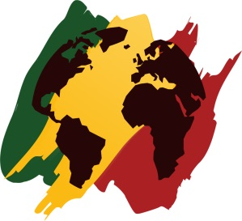
Bayfront Reggae / World Music FestIval

Sponsorship

$5,000 ONE LOVE
Promotional Sponsor Level

A. Sponsor logo placement on produced 30-second radio promotional announcements in support of the event with acknowledgement as official and preferred brand in your product category.

B. Sponsor logo placements on all print promotional materials including:

1. Posters
2. Newspaper Advertising
3. Website (with linkage to your site)

C. 40 tickets to the event for use at your discretion
($3000 value)

D. Banner space at Bayfront Festival Park (total of 4 banners to be provided by sponsor)

E. Right of First Acceptance for renewal of sponsorship for subsequent years, pending mutual agreement

Bayfront Reggae / World Music Festival, LLC, 5477 Mc Quade Road, Duluth, MN 55804
Email: janna@bayfrontworldmusic.com Office: 218-525-8099 Mobile: 218-830-0110
Website: www.bayfrontworldmusic.com
Bayfront Reggae / World Music FestIval

Sponsorship

$2,500 CONSCIOUS
Entertainment Sponsor Level

A. Company name on produced 30-second radio promotional announcement in support of the event.

B. Company name on all print promotional materials including:

1. Posters
2. Newspaper Advertising
3. Web site (with linkage to your site)

C. 20 tickets to the event for use at your discretion
($1500 value)

D. Banner space at Bayfront Festival Park (one total, banner to be provided by sponsor)

Bayfront Reggae / World Music Festival, LLC, 5477 Mc Quade Road, Duluth, MN 55804
Email: janna@bayfrontworldmusic.com Office: 218-525-8099 Mobile: 218-830-0110
Website: www.bayfrontworldmusic.com
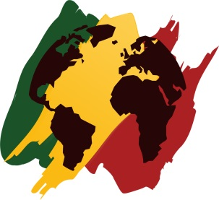
Bayfront Reggae / World Music FestIval

Sponsorship

$2,000 ONE WORLD
Regional Entertainment Sponsor Level

A. Company name on produced 30-second radio promotional announcement in support of the event.

B. Company name on all print promotional materials including:

1. Posters
2. Newspaper Advertising
3. Web site (with linkage to your site)

C. 16 tickets to the event for use at your discretion
($1200 value)

D. Banner space at Bayfront Festival Park (one total, banner to be provided by sponsor)

Bayfront Reggae / World Music Festival, LLC, 5477 Mc Quade Road, Duluth, MN 55804
Email: janna@bayfrontworldmusic.com Office: 218-525-8099 Mobile: 218-830-0110
Website: www.bayfrontworldmusic.com

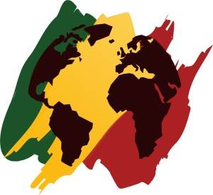
Bayfront Reggae / World Music FestIval

Sponsorship

$1,500 UNITY
Website Sponsor Level

A. Company name sponsorship acknowledgement on print promotional materials including:

1. Posters
2. Newspaper advertising
3. Web site (with linkage to your site)

B. 12 tickets to the event for use at your discretion
($900 value)

Bayfront Reggae / World Music Festival, LLC, 5477 Mc Quade Road, Duluth, MN 55804
Email: janna@bayfrontworldmusic.com Office: 218-525-8099 Mobile: 218-830-0110
Website: www.bayfrontworldmusic.com
Bayfront Reggae / World Music FestIval

Sponsorship

$1000 RESPECT
Sponsor Level

A. Company name sponsorship acknowledgement on print promotional materials including:

1. Posters
2. Newspaper advertising

B. 8 tickets to the event for use at your discretion
($600 value)

Bayfront Reggae / World Music Festival, LLC, 5477 Mc Quade Road, Duluth, MN 55804
Email: janna@bayfrontworldmusic.com Office: 218-525-8099 Mobile: 218-830-0110
Website: www.bayfrontworldmusic.com
Bayfront Reggae / World Music FestIval

Sponsorship

$500 IRIE
Sponsor Level

A. Company name sponsorship acknowledgement on print promotional materials including:

1. Posters
2. Newspaper advertising

B. 4 tickets to the event for use at your discretion
($300 value)

Bayfront Reggae / World Music Festival, LLC, 5477 Mc Quade Road, Duluth, MN 55804
Email: janna@bayfrontworldmusic.com Office: 218-525-8099 Mobile: 218-830-0110
Website: www.bayfrontworldmusic.com
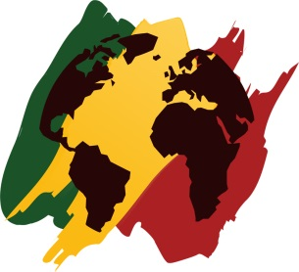
Bayfront Reggae / World Music FestIval

Sponsorship

$250 ROOTS
Sponsor Level

A. Acknowledgement of support

B. 2 tickets to the event
($150 value)

Bayfront Reggae / World Music Festival, LLC, 5477 Mc Quade Road, Duluth, MN 55804
Email: janna@bayfrontworldmusic.com Office: 218-525-8099 Mobile: 218-830-0110
Website: www.bayfrontworldmusic.com

